CODE | GAMBAR | TIKET
S0 | NETWORK  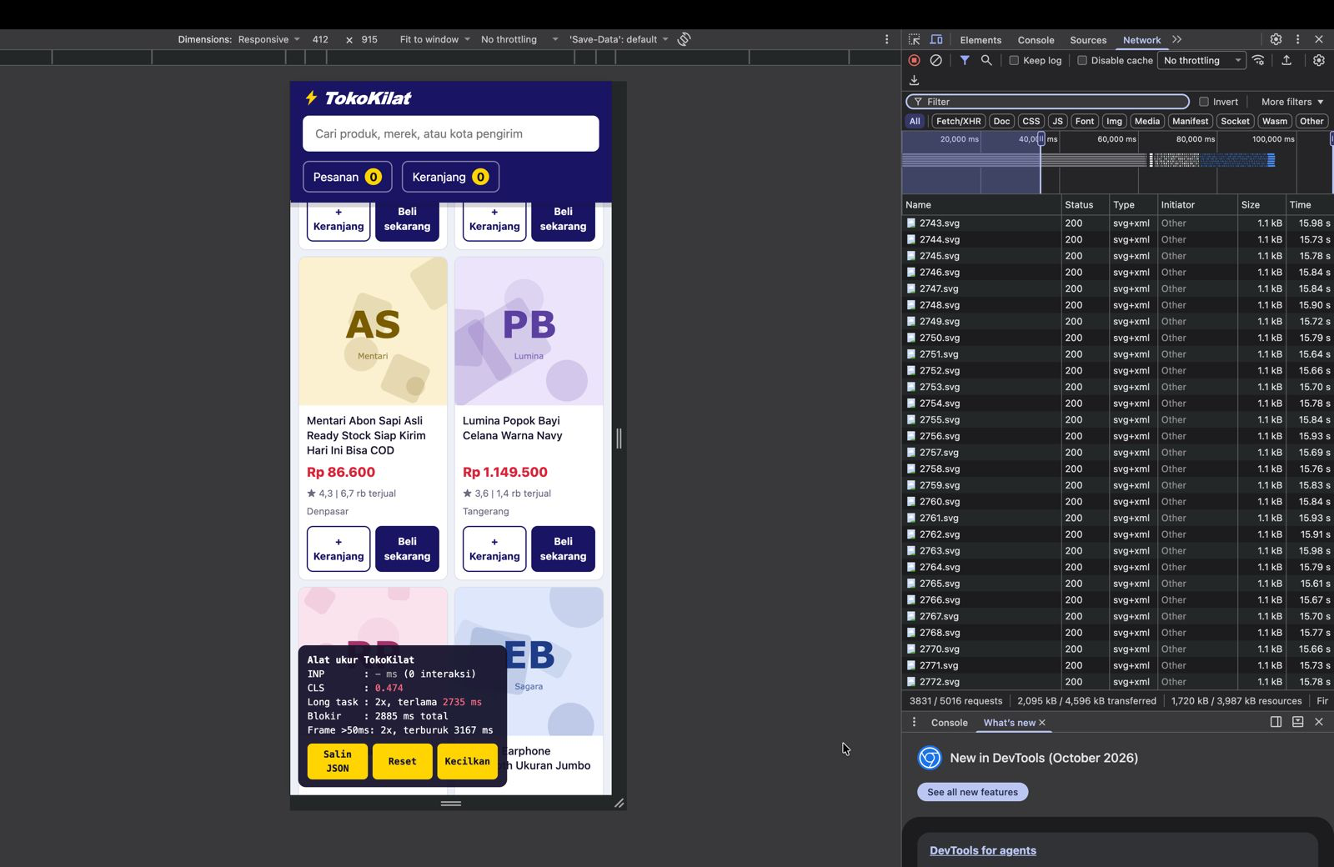 | TK-1078, TK-1081
S1 | 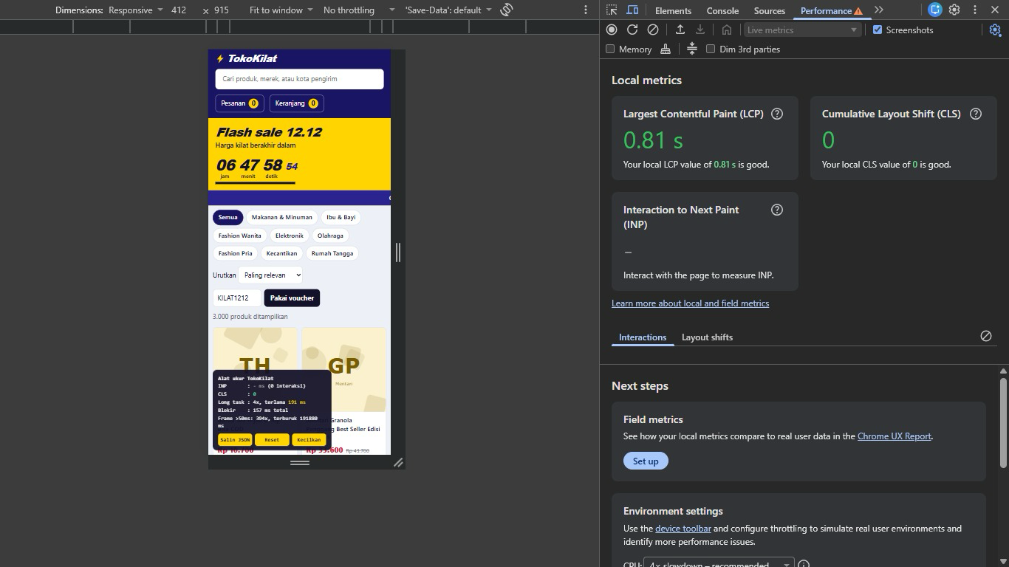  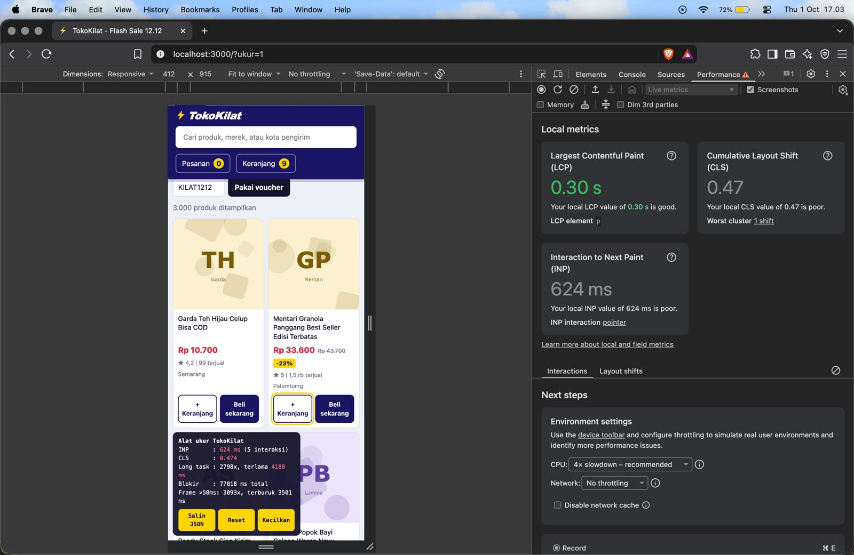 | TK-1041
S2 | 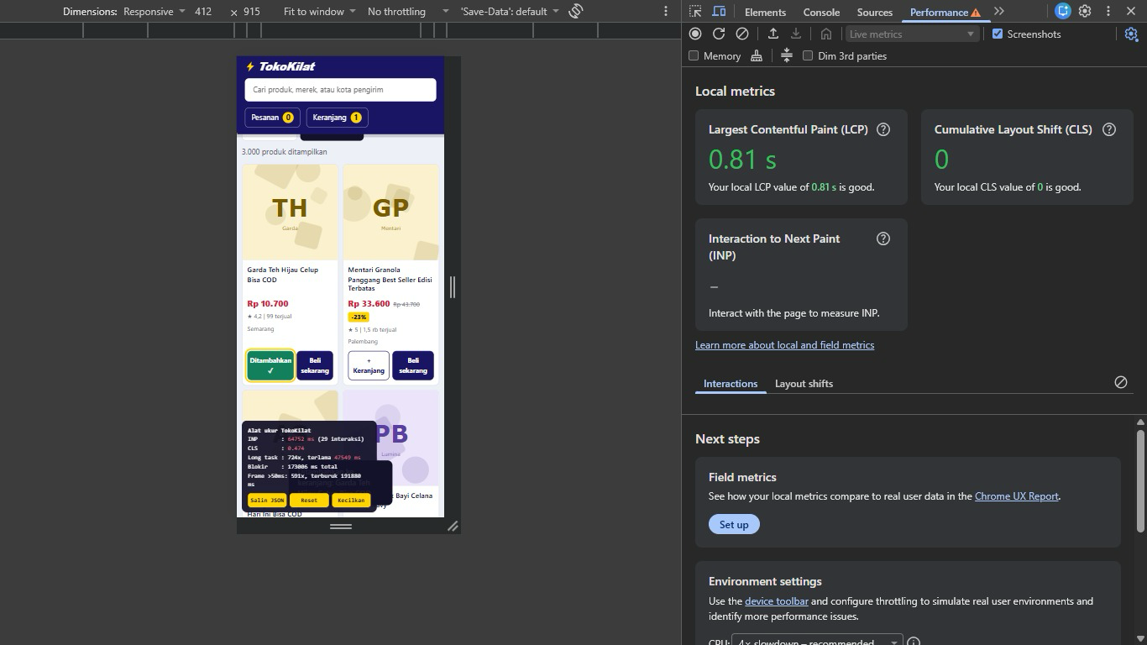 | TK-1044
S3 | 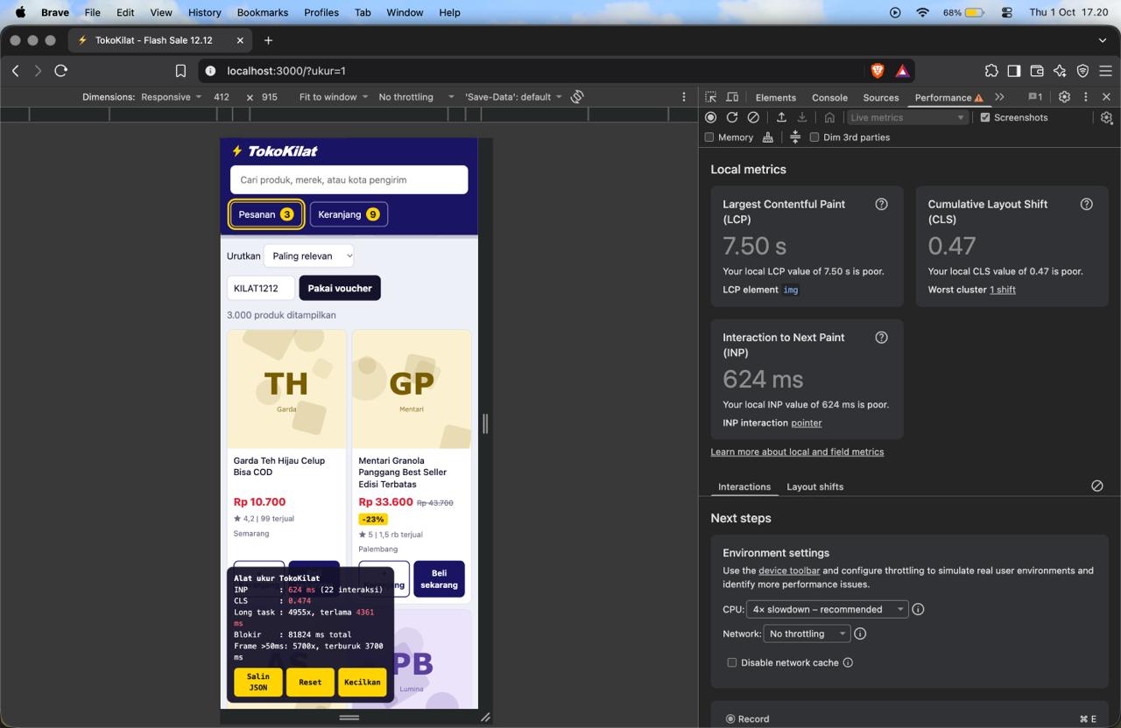  Log terminal:  [pesanan] TK-00001 produk #1 (1 total)  [pesanan] TK-00002 produk #1 (2 total)  [pesanan] TK-00003 produk #1 (3 total)  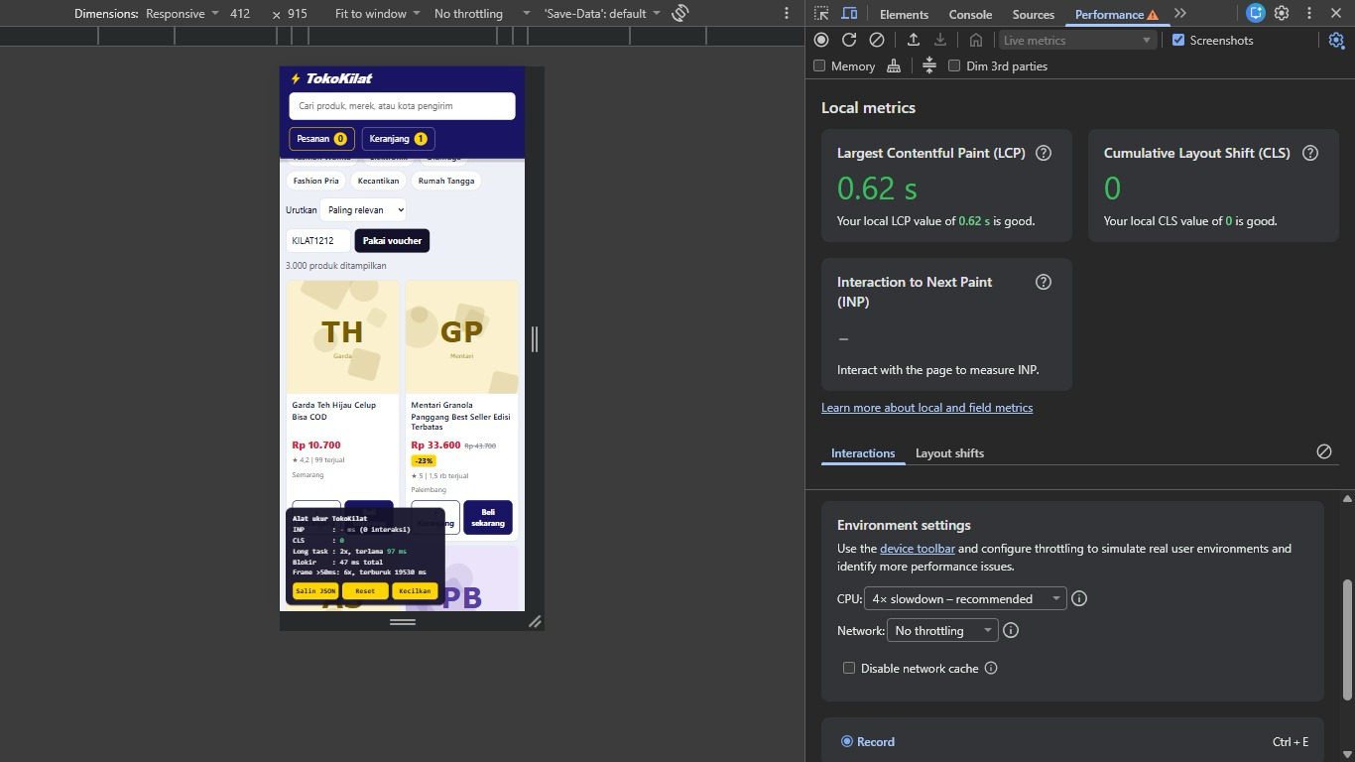  Log terminal  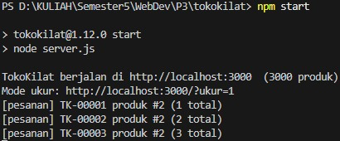 | TK-1052
S4 | 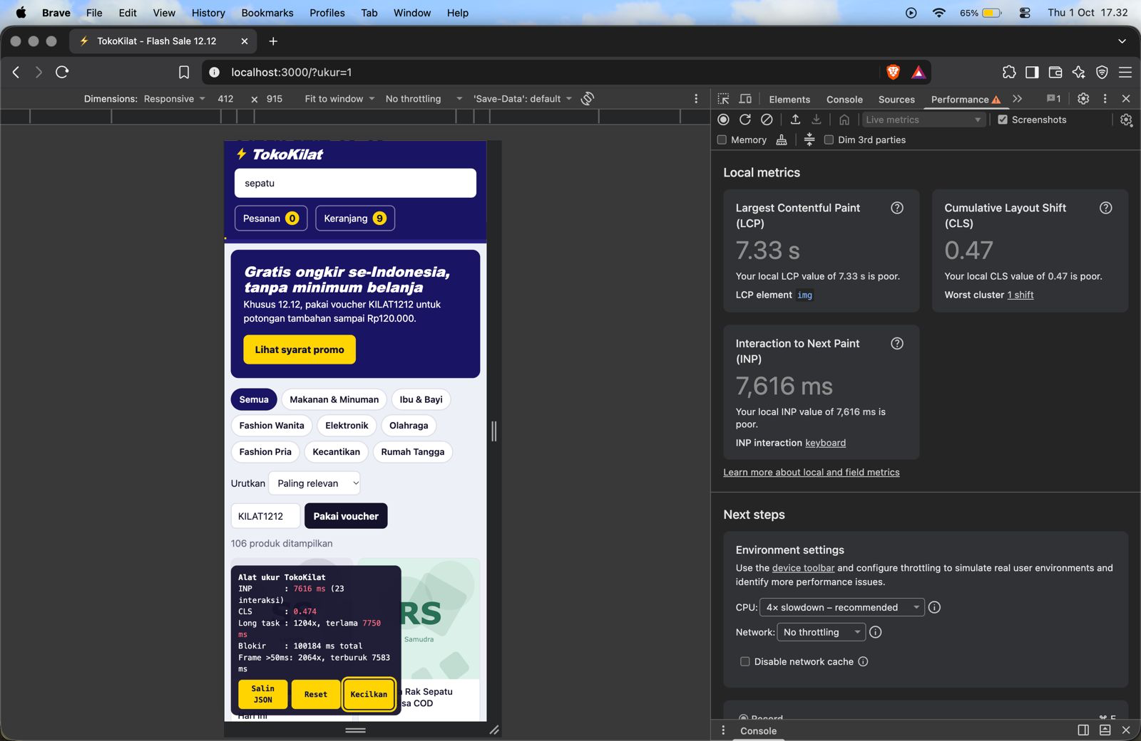 | TK-1057
S5 | 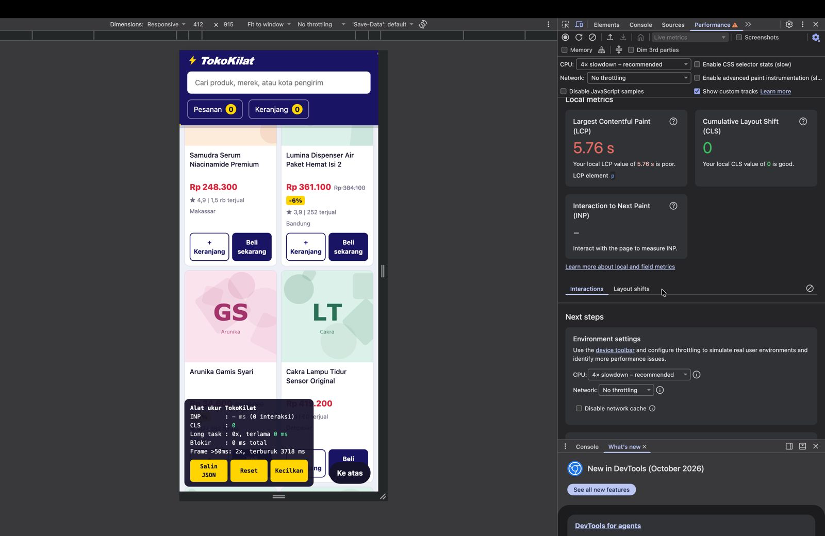  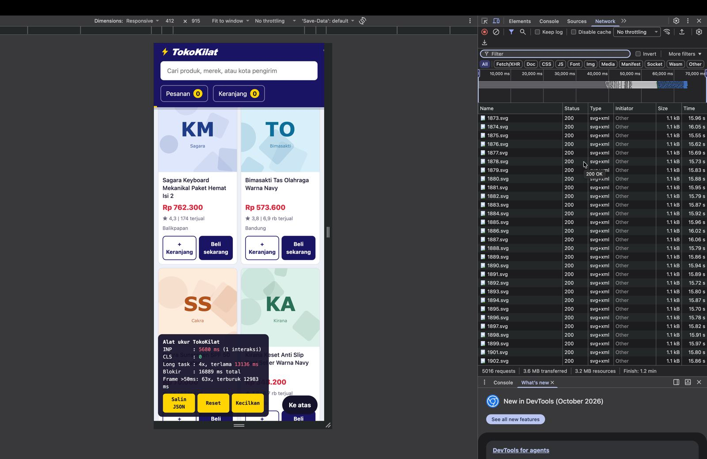  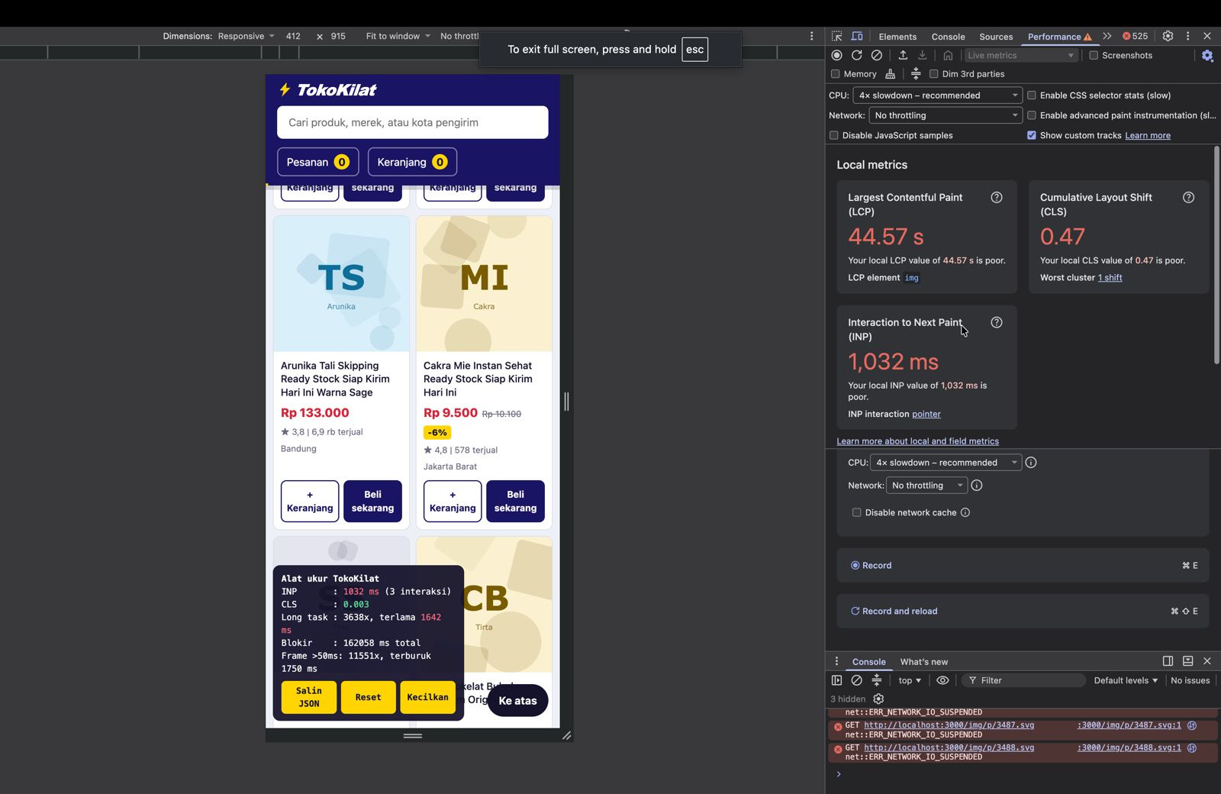  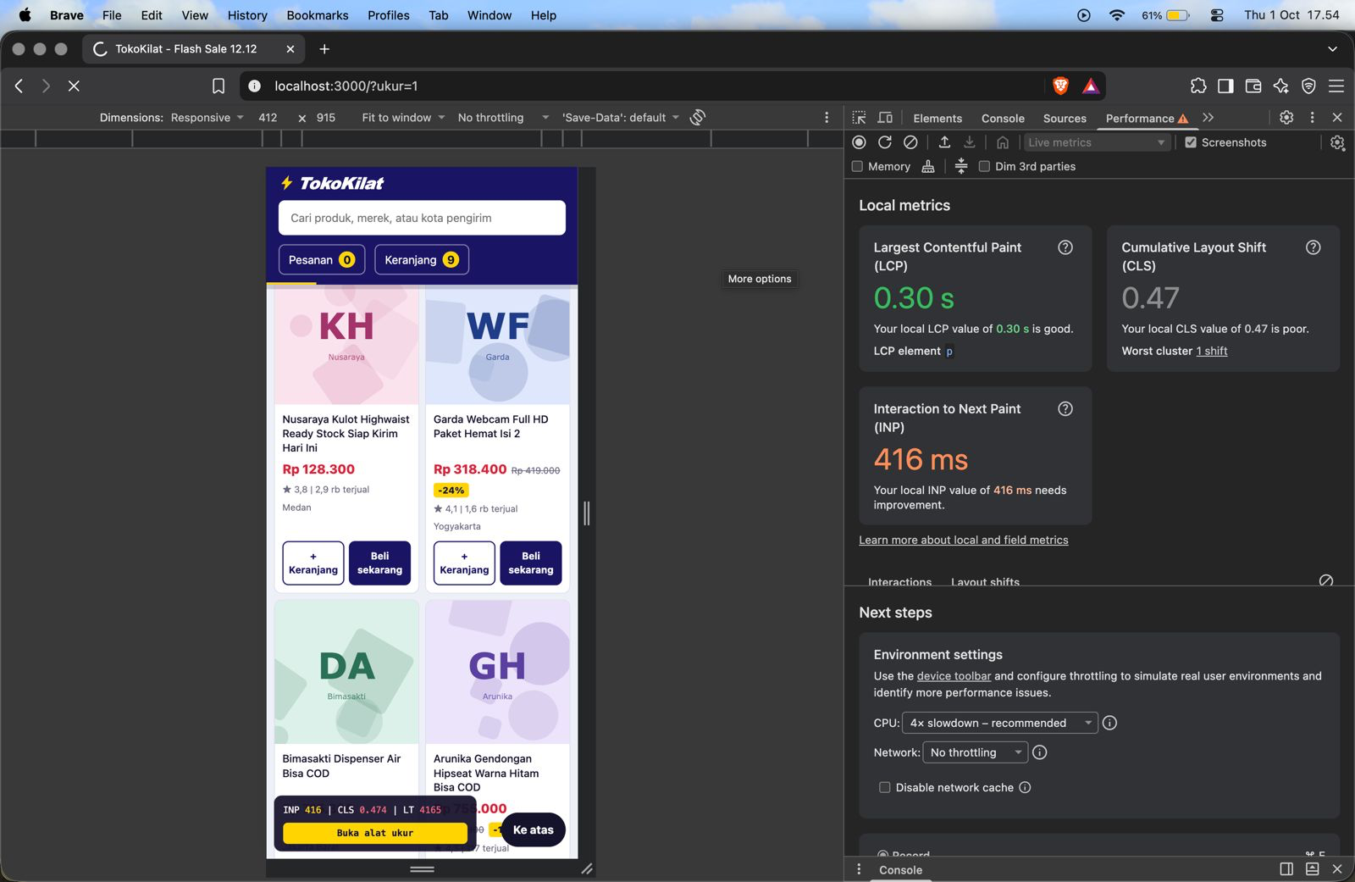 | TK-1063
S6 | 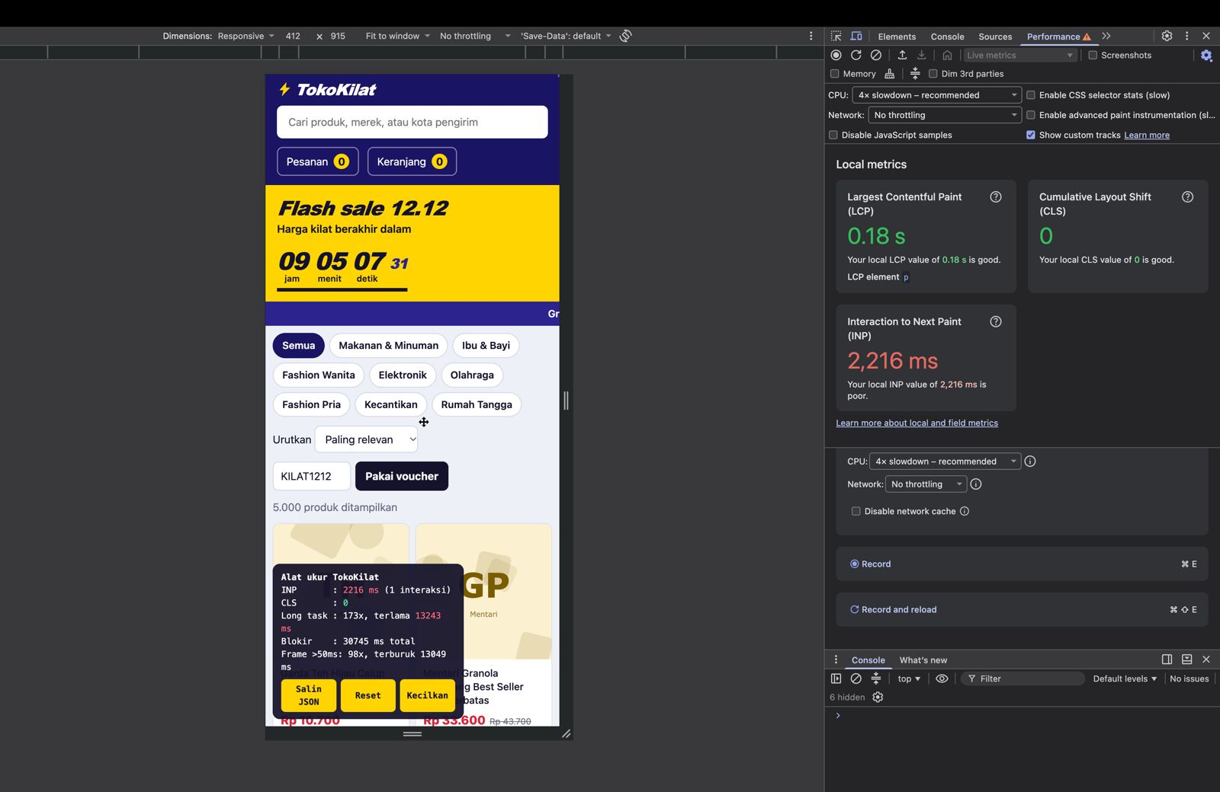  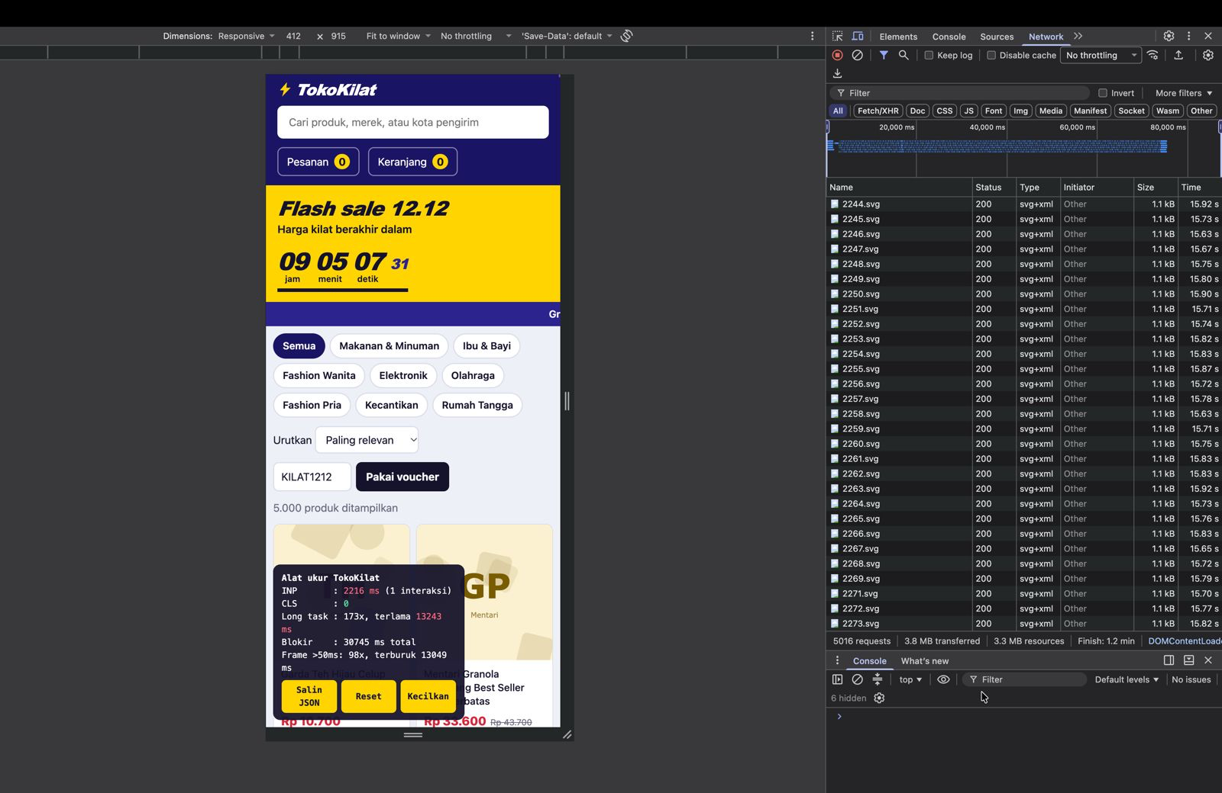  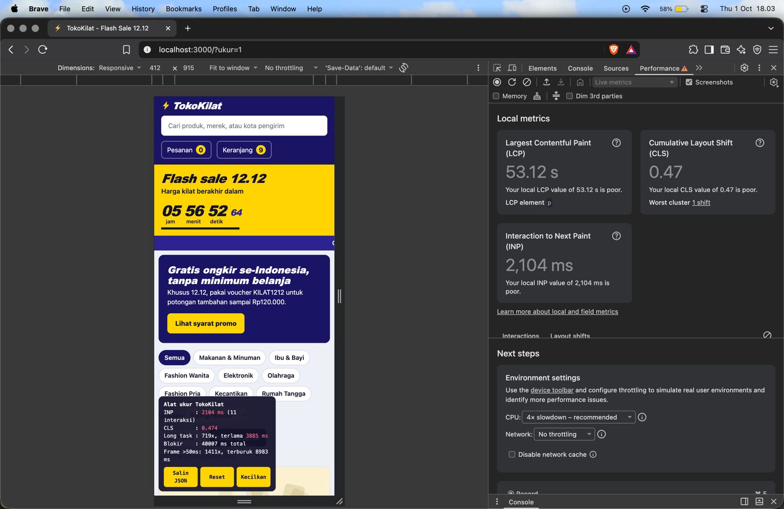 | TK-1070
DI JALANKAN PADA DEVICES:
- MACBOOK AIR M4
- MACBOOK AIR M2
- ASUS A442U

